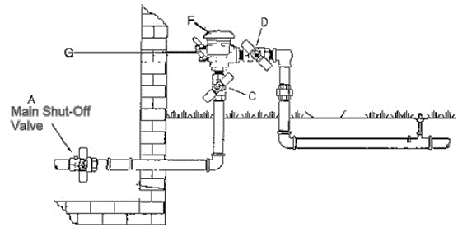

Step 1: Turn the water off in the basement

Step 2: Go outside to the backflow unit you will need a flathead screwdriver and you will turn “G” to a 45-degree angle (both test ports) Not all backflows look like the diagram this is most of all backflows

Step 3: Turn handles “C” and “D” to a 45-degree angle

Step 4: Open drain. If inside the house place a bucket underneath to catch any residual water. (If this continues to leak more than 24 hours after the system has been winterized you will need to contact a plumber to replace your shut off valve)

Step 5: LEAVE THE DRAIN OPEN THROUGH THE WINTER

IF YOU ARE UNSURE HOW TO PREPARE YOUR BACKFLOW FOR A BLOW AND GO WINTERIZATION IT IS THEN BEST TO HAVE A FULL-SERVICE WINTERIZATION DONE TO HELP ENSURE IT IS WINTERIZAED PROPERLY AS USA HOICH IS NOT RESPONSIBLE FOR ANY FREEZE DAMAGE

